Project Planning Phase
Project Planning Template
Date | 11 September 2026
Student Name | Yuvasri Malla
Project Name | Licensed Software Installation Request Management
Maximum Marks | 5 Marks

Product Backlog, Sprint Schedule and Estimation
Sprint | Functional  Requirement (Epic) | User Story / Task | Story  Points | Priority | Student  Name
Sprint-  1 | Foundation | Create ServiceNow application structure, request records, required fields, and basic configuration. | 5 | High | Yuvasri Malla
Sprint-  2 | Catalog & Form | Create Licensed Software Installation Request catalog item, variables, and request form configuration. | 6 | High | Yuvasri Malla
Sprint-  3 | UI/UX | Configure a user-friendly catalog form, variable layout, labels, and portal presentation for requesters. | 5 | High | Yuvasri Malla
Sprint-  4 | Automation | Configure approval flow, Workflow Studio automation, software team assignment, and fulfillment tasks. | 6 | High | Yuvasri Malla
Sprint-  5 | Validation | Perform functional testing, approval/notification validation, SLA checks, and security/access verification. | 4 | High | Yuvasri Malla
Sprint-  6 | Deployment & Docs | Prepare update set/deployment evidence, final documentation, screenshots, results, and presentation material. | 2 | High | Yuvasri Malla
Sprint Schedule
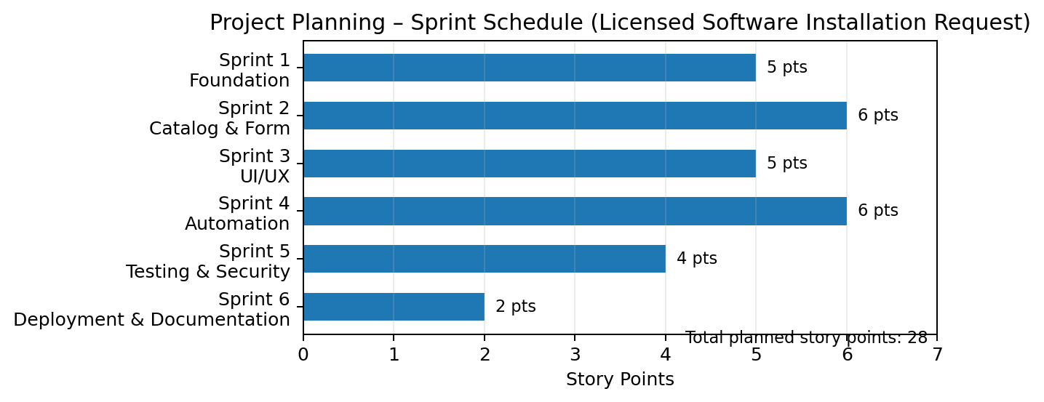

Project Tracker
Work Item | Status | Validation
ServiceNow Application / Foundation | Completed | Application structure and core request configuration prepared.
Licensed Software Request Catalog | Completed | Catalog item created with required request details.
Catalog Variables | Completed | Software, requester, priority, justification, and related variables configured.
User-Friendly Catalog Form | Completed | Form layout and variable presentation validated for requesters.
Approval Process | Completed | Approval condition and approver routing configured.
Workflow Studio Automation | Completed | Request flow configured for approval, task creation, and fulfillment.
Software Installation Task | Completed | Fulfillment task assigned to the software support team.
Notifications | Completed | Approval and task/request notifications configured.
SLA / Service Configuration | Completed | Priority-based service/SLA configuration validated.
Testing & Security | Completed | Functional workflow, access, notification, and validation checks completed.
Deployment & Documentation | Completed | Update-set/deployment evidence and final project documentation prepared.

